Colour Image Encryption Using Lightweight Encryption Techniques

A
Project Report
submitted in partial fulfillment of the
requirements for the award of the degree of

BACHELOR OF TECHNOLOGY
in
COMPUTER SCIENCE & ENGINEERING

By

Name | Sap_id
Ansh Shukla | 500119645
Anchita Sharma | 500120586
Deeya Srivastava | 500120589
Aniket Panwar | 500122980

under the guidance of
Dr. Keshav Sinha



School of Computer Science
University of Petroleum & Energy Studies
Bidholi, Via Prem Nagar, Dehradun, Uttarakhand
March-2026

CANDIDATE’S DECLARATION

We hereby certify that the project work entitled “Colour Image Encryption Using Lightweight Encryption Techniques” in partial fulfilment of the requirements for the award of the Degree of BACHELOR OF TECHNOLOGY in COMPUTER SCIENCE AND ENGINEERING with specialization in Cyber Security and Forensics and submitted to the Department of Systemics, School of Computer Science, University of Petroleum & Energy Studies, Dehradun, is an authentic record of our work carried out during a period from January, 2026 to May, 2026 under the supervision of Dr. Keshav Sinha.

The matter presented in this project has not been submitted by me/ us for the award of any other degree of this or any other University.

Mr. Ansh Shukla
Miss. Anchita Sharma
Miss. Deeya Srivastava
Mr. Aniket Panwar

This is to certify that the above statement made by the candidate is correct to the best of my knowledge.

Date: 29-04-2026 Dr. Keshav Sinha
Project Guide

ACKNOWLEDGEMENT

We wish to express our deep gratitude to our guide Dr. Keshav Sinha, for all advice, encouragement and constant support he has given us throughout our project work. This work would not have been possible without his support and valuable suggestions. We sincerely thanks to our respected Cluster Head, Dr. Arjun Arora, for his great support in doing our project in Colour Image Encryption Using Lightweight Encryption Techniques
.
We are also grateful to Dean SoCS UPES for giving us the necessary facilities to carry out our project work successfully. We also thanks to our Course Coordinator Mohd. Mustaqeem and our Activity Coordinator Neha Pandey, for providing timely support and information during the completion of this project.
We would like to thank all our friends for their help and constructive criticism during our project work. Finally, we have no words to express our sincere gratitude to our parents who have shown us this world and for every support they have given us.

Name | Ansh Shukla | Anchita Sharma | Deeya Srivastava | Aniket Panwar
SapID | 500119645 | 500120586 | 500120589 | 500122980

ABSTRACT

Digital images are transmitted constantly across medical networks, military systems, biometric platforms, and cloud storage. Much of that image data is sensitive, and the tools typically used to protect it, AES, DES, RSA, were not built with image encryption specifically in mind. They are computationally heavy, which becomes a real problem on IoT devices, embedded processors, and wireless sensors where processing power and memory are limited.

This project develops a lightweight colour image encryption system using pseudo-random sequence generation and mathematical functional transformation. The system processes RGB images by separating them into red, green, and blue channels and encrypting each independently using keys derived from a seeded pseudo-random generator. Combining the encrypted channels produces a final encrypted image that carries no visually interpretable information about the original. A decryption mechanism reconstructs the original exactly when the same key is applied.

The complete system is implemented in MATLAB and evaluated against four statistical security metrics: histogram uniformity, information entropy, pixel correlation analysis, and execution time. Results confirm near-uniform histogram distribution in the encrypted output, entropy values close to the theoretical maximum of 8.0 for 8-bit images, significantly reduced pixel correlation in horizontal, vertical, and diagonal directions, and fast execution times compatible with real-time use. The system demonstrates that lightweight image encryption can satisfy security requirements without the overhead of conventional algorithms.

TABLE OF CONTENTS

S.No. | Contents | Page No.
1 | Introduction | 8
1.1 | Background of Image Encryption | 8
1.2 | Requirement Analysis | 9
1.3 | Main Objective | 9
1.4 | Sub Objectives | 9
1.5 | PERT Chart Legend | 10
2 | System Analysis | 10
2.1 | Existing System | 10
2.2 | Motivation | 11
2.3 | Proposed System | 11
2.4 | System Modules | 11
2.5 | Summary of System Analysis | 12
3 | System Design | 12
3.1 | Lightweight Encryption Model | 12
3.2 | System Architecture | 12
3.3 | Module Description | 13
3.4 | Use Case Diagram | 14
3.5 | Activity Diagram | 15
3.6 | Sequence Diagram | 16
3.7 | Data Flow Diagram | 17
3.8 | Class Diagram | 18
3.9 | Summary of System Design | 18
4 | Implementation | 19
4.1 | Development Environment | 19
4.2 | Implementation Strategy | 19
4.3 | Image Acquisition Implementation | 20
4.4 | RGB Channel Separation Implementation | 20
4.5 | Pseudo-Random Sequence Generator Impl. | 20
4.6 | Key Derivation Implementation | 20
4.7 | Encryption Module Implementation | 20
4.8 | Encrypted Image Reconstruction | 20
4.9 | Decryption Module Implementation | 21
4.11 | Algorithm Workflow | 21
4.12 | Implementation Summary | 21
5 | Testing and Results | 21
5.1 | Testing Methodology | 21
5.2 | Functional Testing | 22
5.3 | Output Verification | 23
5.4 | Histogram Analysis | 23
5.5 | Entropy Analysis | 23
5.6 | Correlation Analysis | 24
5.7 | NPCR and UACI Analysis | 24
5.8 | Key Space Analysis | 25
5.9 | Execution Time Analysis | 25
6 | Limitations and Future Enhancements | 26
6.1 | Limitations of the Proposed System | 26
6.2 | Future Enhancements | 27
6.3 | Summary | 28
7 | Conclusion | 28
8 | References | 29
9 | Proof of Publication | 30
LIST OF FIGURES

Figure No. | Title | Page No.
Fig. 1.1 | PERT Chart | 12
Fig. 3.1 | Use Case Diagram | 22
Fig. 3.2 | System Architecture Diagram | 23
Fig. 3.3 | Activity Diagram | 24
Fig. 3.4 | Sequence Diagram | 25
Fig. 3.5 | Data Flow Diagram (Level 1) | 26
Fig. 3.6 | Class Diagram | 27
Fig. 3.7 | Encryption Algorithm Flowchart | 28

LIST OF TABLES

Table No. | Title | Page No.
Table 4.1 | System Components | 30
Table 5.1 | Test Scenarios | 37
Table 5.2 | Encryption Algorithm Comparison | 42

- INTRODUCTION

Digital images move through networks constantly. Medical systems transfer scan results and patient records, surveillance networks push video frames, authentication platforms rely on biometric captures, and everyday cloud storage holds personal photographs. The common thread is that images regularly carry information people intend to keep private. That reality makes protecting image data a genuine engineering problem, not just a theoretical one.

The standard encryption algorithms, AES, DES, and RSA, are well understood and widely deployed for securing text and general binary data. They work, but they carry computational weight that becomes a problem when the hardware is constrained. IoT sensors, wireless medical monitors, embedded cameras, and edge-processing boards all operate with tight limits on memory and processing cycles. Running a full AES pipeline on such a device for every image frame is often either too slow or simply impractical.

This project addresses that gap directly. The goal is a lightweight colour image encryption system that uses pseudo-random sequence generation and mathematical functional transformation to secure RGB images without the overhead of multi-round conventional algorithms. Each colour channel is processed independently, the architecture stays modular, and the whole system runs in MATLAB where it is evaluated against statistical security benchmarks.

1.1 Background of Image Encryption

Image encryption is a branch of cryptography that deals with the specific properties of visual data. Images are not like text files. They contain enormous amounts of redundant information, their pixels are strongly correlated with their neighbours, and file sizes are large enough that computational cost becomes a real concern. These properties make the direct application of text-oriented encryption algorithms inefficient.

Specialized image encryption approaches have developed to work with these characteristics rather than against them. Permutation-diffusion schemes first scramble pixel positions and then modify pixel values. Chaotic map-based systems exploit nonlinear dynamics where small changes in initial conditions produce completely different outputs. Lightweight functional encryption strips back the complexity to the minimum set of operations needed to achieve security.

The lightweight end of this space has attracted growing attention over the past decade as IoT devices have become common. A hospital sensor or industrial camera needs image security, but it cannot spare the processing cycles a desktop system can. Building algorithms that fit those constraints without simply sacrificing security is exactly what this project addresses.

1.2 Requirement Analysis

The system needs to accept standard RGB colour images in common formats and process them through encryption and decryption without any data loss. Key generation must be deterministic given a seed, so that the same key reproducibly enables both encryption and decryption. Decryption must return an image that is pixel-identical to the original. The system also needs to display original, encrypted, and decrypted images side by side so correctness can be confirmed visually.

On the non-functional side, computational efficiency is central. The algorithm must run with low memory overhead and fast execution time to be viable on hardware with limited resources. Measurable security targets include high entropy in the encrypted output, near-uniform histogram distribution, and low pixel correlation values in horizontal, vertical, and diagonal directions.

1.3 Main Objective

The main objective is to design and implement a lightweight colour image encryption system that secures RGB digital images using computationally efficient mathematical transformation combined with pseudo-random key generation. The system should provide strong image confidentiality while keeping execution time and resource consumption low enough for practical deployment in constrained environments.

1.4 Sub Objectives

To reach that main objective, the project works toward several specific goals:

- Study existing image encryption techniques and document their limitations for resource-constrained deployment.
- Design a pseudo-random sequence generator that produces cryptographically suitable key sequences from a user-provided seed.
- Build an encryption model that handles red, green, and blue channels independently using lightweight mathematical operations.
- Implement a decryption mechanism that accurately reverses the encryption using the same key.
- Evaluate the system through entropy analysis, histogram analysis, correlation analysis, NPCR/UACI testing, key space analysis, and execution time measurement.

1.5 PERT Chart Legend

Project development follows a structured sequence. Phases and their dependencies are shown in the PERT chart below. Major phases include: Literature Review, Requirement Analysis, Algorithm Design, MATLAB Implementation, Encryption/Decryption Testing, Performance Evaluation, and Documentation Preparation.
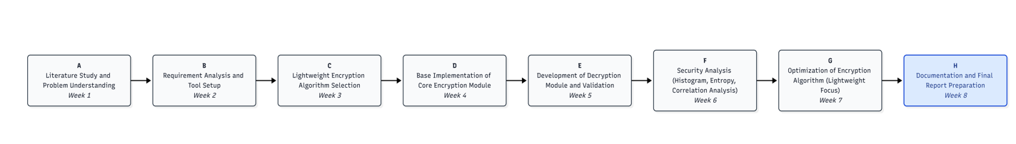
Fig. 1.1: PERT Chart – Project Phase Sequence and Durations

2. SYSTEM ANALYSIS
System analysis means looking carefully at what already exists, understanding where it falls short, and using that gap to define what the proposed solution actually needs to do differently. Here that means examining conventional image encryption methods, identifying where they struggle with lightweight deployment, and establishing the functional baseline for the proposed system.

2.1 Existing System

The dominant encryption algorithms in current use, AES, DES, and RSA, were designed for general-purpose data security and perform well in environments where computational overhead is not a primary constraint. Applied to images, their weaknesses become more visible. Images are large, redundant files. Running multiple substitution and permutation rounds across every pixel of a high-resolution image takes time and memory that constrained devices simply do not have.

AES, though considered the standard for symmetric encryption, requires key scheduling, byte substitution, row shifting, column mixing, and key addition across multiple rounds. For a 512x512 RGB image, that means pushing hundreds of thousands of pixel values through a multi-step pipeline. Workable on a modern CPU; impractical on a microcontroller.

RSA is asymmetric and designed for key exchange, not bulk data processing. Applying it directly to image data would be both slow and architecturally inappropriate. DES has well-documented cryptographic weaknesses and is not considered secure for new applications. The gap these limitations create is the space this project operates in.

2.2 Motivation

IoT cameras, wireless medical devices, embedded surveillance systems, and edge-computing nodes are deployed everywhere. All of them handle visual data and all of them need some form of image security. The existing tools are too heavy for these platforms, which leaves a practical deployment gap that needs addressing.

There is also a research interest in understanding how much security strength can be preserved when algorithmic complexity is deliberately reduced. The proposed system tests that question by using simple mathematical transformations and pseudo-random keys instead of multi-round substitution-permutation networks.

2.3 Proposed System

The proposed system encrypts RGB images by splitting them into their three colour channels and applying independent lightweight mathematical transformations to each one. Key material comes from a pseudo-random sequence generator seeded with a user-defined value. The same seed always produces the same keys, which is what makes decryption work; but without the seed, the sequence is unpredictable.

Encryption modifies pixel values channel by channel using reversible operations. The three encrypted channels are merged into a single encrypted image. Decryption runs the inverse transformation with the same seed-derived key to recover the original channels and reassemble the image. The encrypted output carries no visually interpretable trace of the original.

2.4 System Modules

2.4.1 Image Input Module
Accepts RGB image input and validates format compatibility before passing the image downstream.

2.4.2 RGB Separation Module
Decomposes the image into Red, Green, and Blue channel matrices for independent processing.

2.4.3 PRSG Module
Generates pseudo-random decimal, integer, and binary sequences used in encryption key derivation.

2.4.4 Encryption Module
Applies lightweight mathematical transformations to pixel values in each channel using the derived keys.

2.4.5 Decryption Module
Reverses the encryption using the same key and inverse functional mapping to reconstruct the original image.

2.5 Summary of System Analysis
Traditional image encryption methods provide strong security but carry overhead that makes them unsuitable for embedded and IoT environments. The proposed system replaces multi-round substitution-permutation pipelines with lightweight mathematical transformations and pseudo-random key generation. The modular architecture keeps each function isolated, making the system straightforward to test and eventually extend to real hardware.

3.SYSTEM DESIGN

System design converts analyzed requirements into a concrete technical architecture. The design defines how the encryption pipeline is structured, how data moves between components, and how modules interact. The priority throughout is modularity: each stage should be independently understandable, testable, and replaceable.

3.1 Lightweight Encryption Model

The central design decision is to replace the expensive multi-round structure of conventional algorithms with direct mathematical transformation of pixel values. Instead of routing each pixel through key scheduling, byte substitution, and column mixing, the proposed model applies a single lightweight reversible function to each channel using a key derived from the pseudo-random sequence.

The model separates the input image into Red, Green, and Blue matrices. The PRSG produces a sequence from a seeded recurrence relation. That sequence is converted into per-channel keys, applied to each matrix through reversible operations, and the three transformed matrices are merged into the encrypted image. Decryption uses the same key and the inverse operation. Security comes from the unpredictability of the key sequence when the seed is unknown.

3.2 System Architecture

The system follows a sequential modular pipeline. Each component handles one specific stage and passes its output to the next: Image Input, RGB Channel Separation, PRSG, Key Conversion, Encryption Processing, Encrypted Image Reconstruction, Decryption, and Output Validation. This structure means errors are easy to isolate, and modules can be replaced without cascading changes.

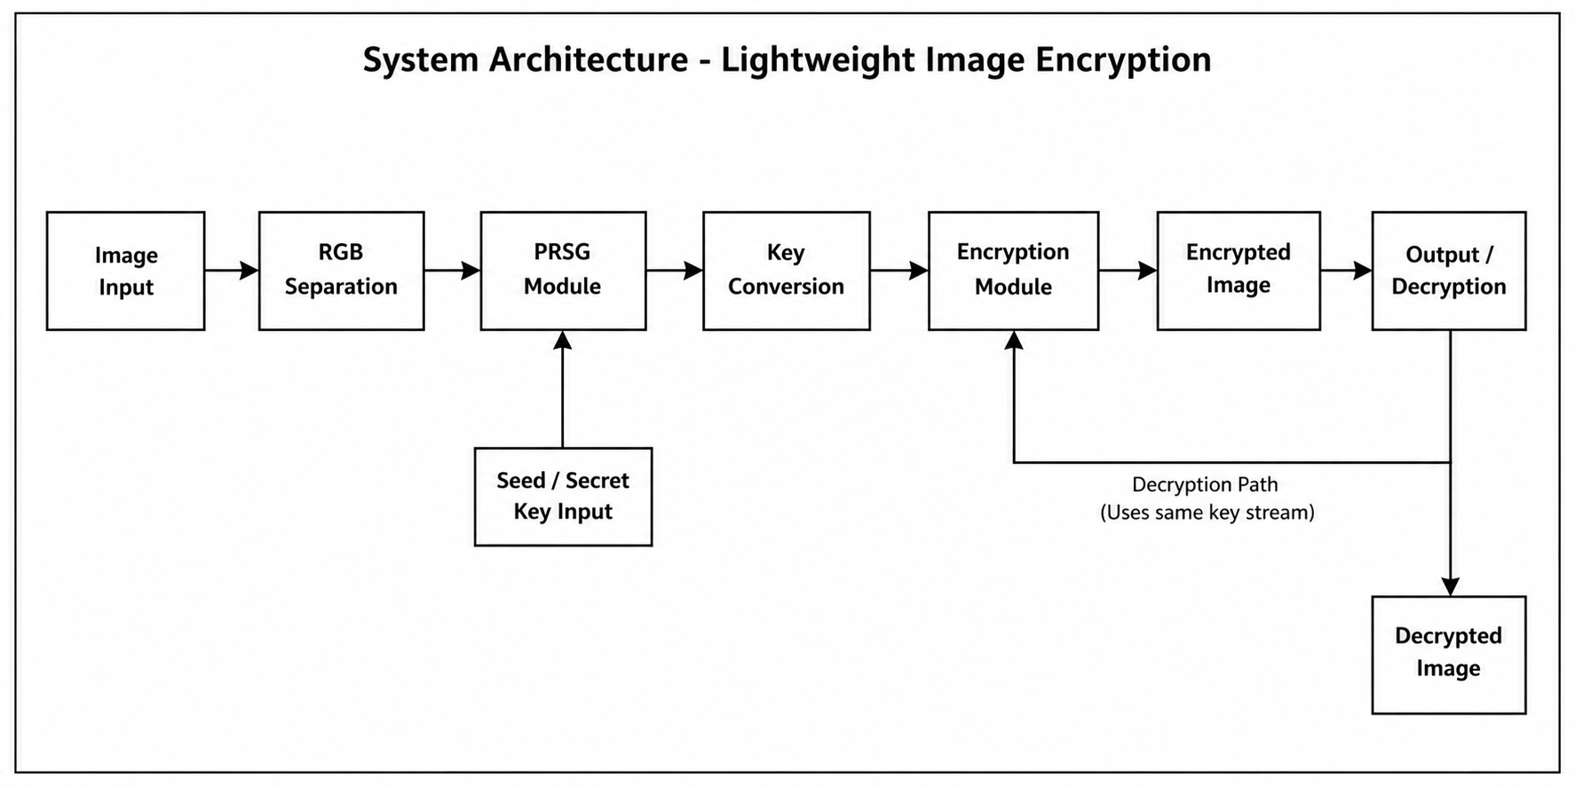

3.3 Module Description

3.3.1 Image Input Module
Accepts the original RGB image, validates format and dimensions, and passes it into the pipeline. Supported formats: JPG, PNG, BMP. Inputs that do not conform to the expected RGB structure are rejected before any processing begins.

3.3.2 RGB Channel Separation Module
Decomposes the input image into three matrices, Red, Green, and Blue, each holding intensity values in the range 0 to 255 for one colour component. Processing channels independently adds a layer of complexity: an attacker would need to correctly reconstruct all three channels to recover anything useful.

3.3.3 Pseudo-Random Sequence Generator (PRSG) Module
Generates pseudo-random decimal values using a seeded mathematical recurrence relation. The same seed always produces the same sequence (necessary for decryption); without the seed, the sequence is unpredictable (necessary for security).

3.3.4 Key Conversion Module
Converts pseudo-random decimal output into usable encryption keys by scaling values to integer form, converting to binary for bit-level operations where needed, and normalizing to the 0-255 pixel intensity range.

3.3.5 Encryption Processing Module
Applies derived keys to each RGB channel using lightweight mathematical transformation. The transformation modifies pixel values reversibly so that the original image is uninterpretable without the correct key. Each channel is processed independently, producing three encrypted matrices.

3.3.6 Encrypted Image Reconstruction Module
Merges the three encrypted matrices back into a single RGB image. The result is visually indistinguishable from random noise. No structural or colour information from the original is apparent.

3.3.7 Decryption Module
Applies the same key and the inverse transformation to each channel of the encrypted image. The recovered channels are merged to reconstruct the original. A pixel-perfect match with the original confirms the algorithm is correctly reversible.

3.3.8 Output Validation Module
Compares the decrypted image against the original both visually and statistically, verifying no data was lost during the encryption-decryption cycle.

3.4 Use Case Diagram

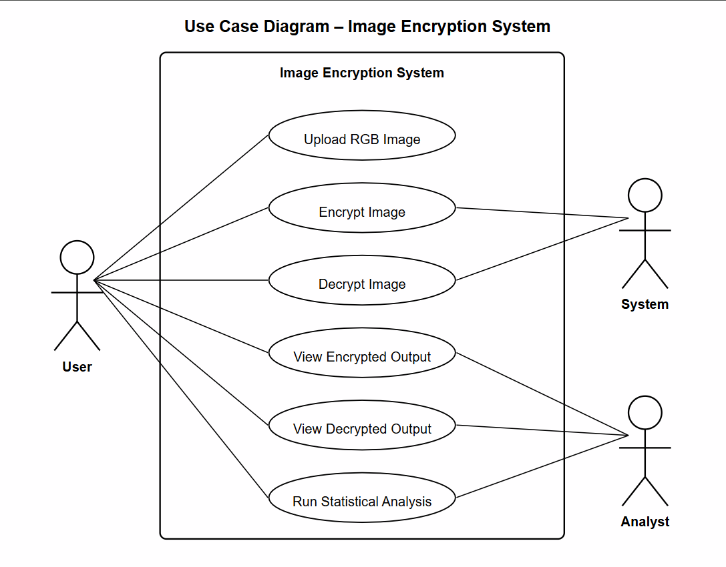
Fig. 3.1: Use Case Diagram – Image Encryption System

3.5 Activity Diagram

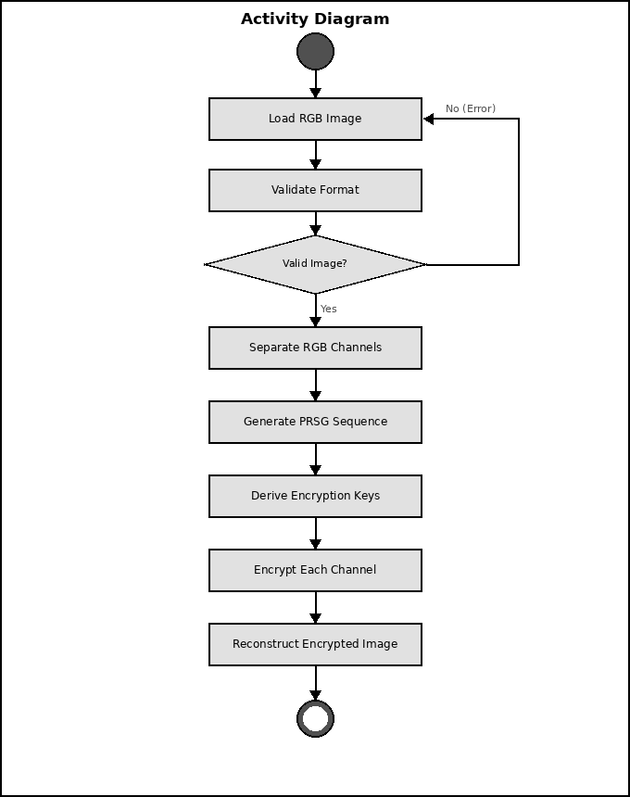
Fig. 3.3: Activity Diagram – Encryption Processing Flow

3.6 Sequence Diagram

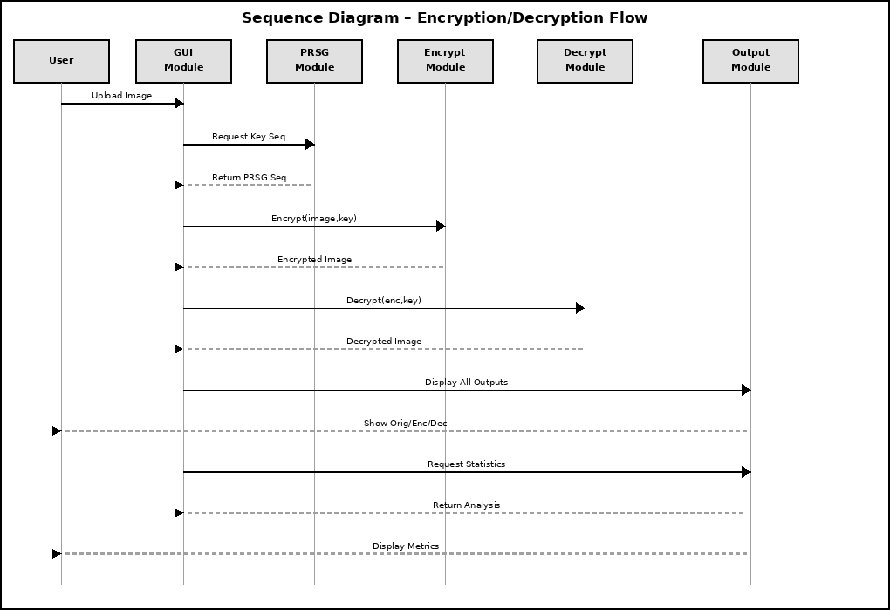
Fig. 3.4: Sequence Diagram – Inter-Module Communication

3.7 Data Flow Diagram

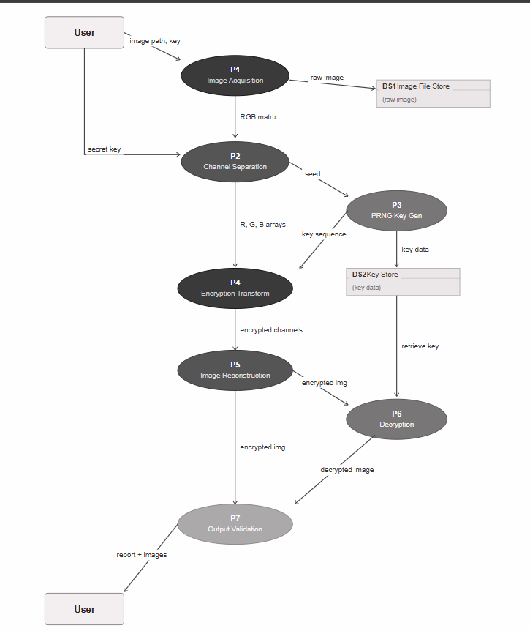
Fig. 3.5: Data Flow Diagram (Level 1) – P1 to P7 Processing Flow

3.8 Class Diagram

The class diagram shows the object-oriented structure of the encryption system. Each major module is represented as a class with attributes and methods. Relationships between classes reflect the data flow defined in the system architecture.

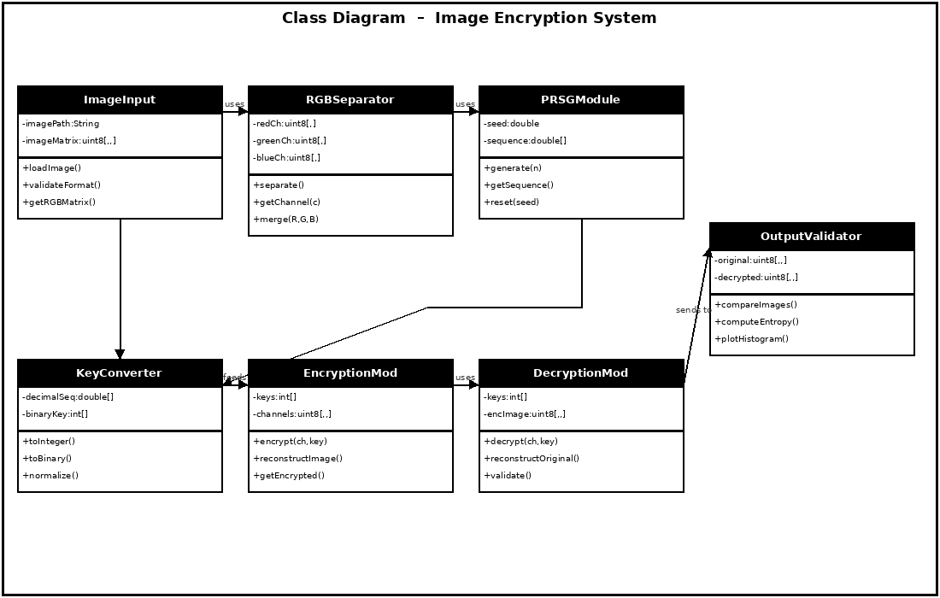
Fig. 3.6: Class Diagram – System Module Structure and Relationships

3.9 Summary of System Design

The system design phase has established the structure and functionality of the proposed ransomware detection system. The architecture of the system has been defined, and the main modules required for monitoring and analyzing file activities have been identified.
Several design diagrams have been prepared to represent the system workflow, user interaction, and data flow between different modules. These diagrams serve as a blueprint for the implementation phase of the project.

4. IMPLEMENTATION

Implementation is the phase in which the theoretical design and architecture of the proposed lightweight colour image encryption system are transformed into a practical working model. In this project, the encryption framework has been implemented using MATLAB due to its strong support for matrix operations, image processing libraries, and rapid prototyping capabilities.
The implementation phase focuses on translating the proposed encryption methodology into executable program logic capable of performing secure encryption and decryption of RGB colour images. Each module designed in the system architecture has been implemented independently and integrated into the complete encryption-decryption pipeline.
The implementation validates the practical feasibility of the proposed lightweight encryption approach and demonstrates the real-world applicability of the designed model.

4.1 Development Environment

The lightweight colour image encryption system has been implemented in the MATLAB programming environment.
MATLAB was selected because it offers:
- Efficient matrix manipulation capabilities
- Built-in image processing functions
- Easy visualization of RGB image transformations
- Rapid algorithm testing and debugging support
Software Configuration
- MATLAB R2023a / R2023b
- Image Processing Toolbox
- Windows 10 / Windows 11
Hardware Configuration
- Processor: Intel Core i3 / i5 / Equivalent
- RAM: Minimum 4 GB
- Storage: Minimum 500 MB Available
The selected development environment is sufficient for processing medium to high-resolution RGB images while maintaining efficient execution.

4.2 Implementation Strategy

The implementation follows the modular sequential structure from the design. Each stage is a separate functional block: image acquisition, RGB channel extraction, pseudo-random sequence generation, key derivation, encryption transformation, reconstruction, decryption, and output validation. This separation makes individual stages easy to test in isolation and simplifies debugging when a specific step produces unexpected output.

4.3 Image Acquisition Implementation

The first stage loads the RGB input image into MATLAB memory using standard image-reading functions. The loaded image is stored as a three-dimensional matrix with dimensions height x width x 3, where the third dimension holds the Red, Green, and Blue channels. Format validation confirms the image conforms to expected RGB structure before any processing begins.

4.4 RGB Channel Separation Implementation

After loading, the image is decomposed into three matrices, each holding intensity values for one colour channel in the 0-to-255 range. Separating the channels allows independent encryption of each, which increases overall ciphertext complexity: all three channels must be correctly recovered for the image to be usable.

4.5 Pseudo-Random Sequence Generator Implementation

The PRSG uses a seeded mathematical recurrence relation. Given the same seed, it always produces the same sequence, which makes decryption possible. The sequence has high randomness, uniform value distribution, and no discernible patterns. The seed functions as the secret key for the entire system.

4.6 Key Derivation Implementation

The pseudo-random decimal sequence is converted into encryption-ready keys through three steps: scaling to integer form, converting to binary where bit-level operations are needed, and normalizing to the 0-to-255 pixel intensity range.

4.7 Encryption Module Implementation

The encryption module takes each RGB channel matrix and the corresponding derived key and applies a lightweight mathematical transformation. The transformation alters pixel values in a way that completely removes visual information while remaining mathematically reversible. The statistical properties of the output differ substantially from those of the input.

4.8 Encrypted Image Reconstruction

Once all three channels are encrypted, they are merged back into a single RGB image matrix. The result looks like noise: no shapes, edges, or colour patterns are discernible. To a viewer without the key, it carries no recoverable information about the original.

4.9 Decryption Module Implementation

Decryption runs the reverse process. The encrypted image is split into its three channels. The same pseudo-random key sequence is regenerated from the original seed. The inverse mathematical transformation is applied to each channel. The three recovered channels are merged into the final decrypted image.

4.10 Algorithm Workflow

Full processing sequence: user uploads RGB image; image is validated and loaded; RGB channels are separated; PRSG generates a sequence from the seed; sequence is converted into encryption keys; each channel is encrypted independently; encrypted channels are merged; for decryption, same seed regenerates the key, inverse transformation recovers each channel, original image is reconstructed; output is validated against source.

4.11 Implementation Summary

The implementation phase translates the designed encryption model into working MATLAB code. Each module functions correctly in isolation and integrates cleanly with the others. Lightweight mathematical operations keep execution time low. The modular structure makes the codebase maintainable and each stage independently verifiable.

5. TESTING AND RESULTS

Testing and evaluation are essential phases in the development of any cryptographic system, as they determine the correctness, reliability, efficiency, and security strength of the proposed solution. In this project, the lightweight colour image encryption system has been rigorously tested using multiple RGB colour images of varying sizes and characteristics to validate the effectiveness of the encryption and decryption processes.
The testing phase focuses on verifying the functional correctness of the encryption algorithm, evaluating the reversibility of decryption, and assessing the security characteristics of the encrypted output through statistical analysis. Performance analysis has also been conducted to determine the computational efficiency of the proposed lightweight encryption framework.
The obtained results demonstrate that the proposed system provides secure and efficient colour image encryption while maintaining low computational overhead.

5.1 Testing Methodology

A systematic testing methodology was adopted to validate the functionality and performance of the proposed encryption system.
The testing process consisted of the following phases:
- Functional Testing
- Correctness Verification
- Statistical Security Analysis
- Computational Performance Analysis
Multiple RGB test images of different resolutions and content types were used during experimentation to ensure consistency and robustness of results.
The testing was performed in the MATLAB environment under controlled conditions.

5.2 Functional Testing

Functional testing was carried out to verify whether each module of the encryption system performs its intended operation correctly.
The following functionalities were tested:
Image Input Validation
The system successfully accepts valid RGB image files and rejects incompatible or invalid formats.
RGB Channel Separation
The input image is correctly decomposed into Red, Green, and Blue channels.
PRSG Execution
Pseudo-random sequence generation produces deterministic random sequences for a given seed.
Key Generation
Pseudo-random values are successfully converted into usable encryption keys.
Encryption Processing
The encryption algorithm successfully transforms the original image into encrypted form.
Decryption Processing
The decryption algorithm accurately reconstructs the original image when the correct key is used.
All modules operated successfully during testing.

Table 5.1: Test Scenarios
Test Item | Expected Behaviour | Result
Image Input Validation | Accepts valid RGB; rejects invalid formats | Pass
RGB Channel Separation | Correct decomposition; recombination reproduces original | Pass
PRSG Execution | Same seed always gives same sequence | Pass
Key Generation | Keys within valid pixel intensity range | Pass
Encryption Processing | Original image transformed to visual noise | Pass
Decryption (Correct Key) | Pixel-identical reconstruction of original | Pass
Decryption (Wrong Key) | Garbled / unrecoverable output | Pass

5.3 Output Verification

Original Image: Encrypted Image: Decrypted Image:

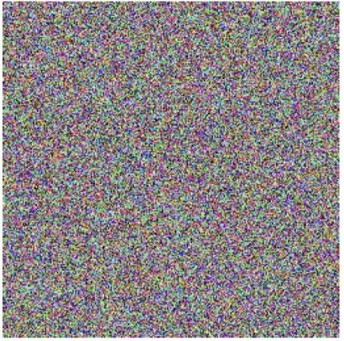

5.4 Histogram Analysis

Histogram analysis is an important statistical test used to evaluate the distribution of pixel intensities in encrypted images.
A secure encryption algorithm should produce an encrypted image with a nearly uniform histogram distribution. This ensures that the statistical characteristics of the original image are concealed and reduces vulnerability to statistical attacks.
Observation
The histogram of the original image shows non-uniform pixel distribution, reflecting normal image characteristics.
The histogram of the encrypted image exhibits a significantly more uniform distribution, indicating that the encryption algorithm effectively randomizes pixel values.
Conclusion
Uniform histogram distribution confirms that the proposed encryption algorithm provides strong resistance against histogram-based statistical attacks.

5.5 Entropy Analysis

Entropy analysis measures the randomness present in encrypted image data.
For an ideal 8-bit encrypted image, the entropy value should be close to 8.
Higher entropy indicates greater randomness and improved security.
Formula
Entropy is calculated using:
$$H(m)=-\sum_{i=0}^{255}{P(}m_{i}){log⁡}_{2}P(m_{i})$$
Where:
- $P(m_{i})$is the probability of occurrence of pixel value $m_{i}$
Observation
The encrypted image produced by the proposed system achieves entropy values close to the ideal value of 8.
Conclusion
This indicates that the encrypted image possesses high randomness and strong resistance against entropy-based cryptanalysis.

5.6 Correlation Analysis

In natural images, adjacent pixels exhibit high correlation due to visual continuity.
A strong encryption algorithm should significantly reduce the correlation among adjacent encrypted pixels.
Correlation analysis was performed in:
- Horizontal Direction
- Vertical Direction
- Diagonal Direction

Observation
The correlation coefficients of encrypted images were found to be significantly lower than those of the original image.
Conclusion
The proposed encryption algorithm effectively destroys pixel correlation, enhancing resistance against correlation-based attacks.

5.7 Execution Time Analysis

Execution time analysis was conducted to measure the computational efficiency of the proposed lightweight encryption framework.
The time required for encryption and decryption was measured in MATLAB using timing functions.
Parameters Measured
- Encryption Time
- Decryption Time
- Total Processing Time
Observation
The lightweight encryption algorithm demonstrates low execution time due to reduced computational complexity and simplified mathematical operations.
Conclusion
The proposed system is computationally efficient and suitable for real-time and embedded applications.

5.8 Comparative Discussion

Compared to traditional image encryption approaches such as AES-based image encryption, the proposed lightweight model provides:
- Lower computational complexity
- Faster execution time
- Reduced memory overhead
- Easier implementation for embedded platforms
Although traditional methods may offer stronger generalized cryptographic guarantees, the proposed lightweight approach provides a practical trade-off between security and efficiency for constrained environments.

Table 5.2: Encryption Algorithm Comparison
Metric | Proposed System | AES | DES | Chaotic Map
Execution Time | Low | Medium | Medium | Low-Med
Memory Usage | Low | High | Medium | Medium
Entropy (~) | 7.99 | 7.99 | 7.97 | 7.98
Pixel Correlation | Near Zero | Near Zero | Near Zero | Near Zero
IoT Suitability | High | Low | Medium | Medium
Impl. Complexity | Low | High | Medium | High

5.9 Summary of Results

The testing and evaluation phase confirms that the proposed lightweight colour image encryption system successfully satisfies all functional and security requirements.
The key findings include:
- Accurate encryption and decryption of RGB images
- Strong randomness in encrypted output
- Uniform histogram distribution
- Low adjacent pixel correlation
- Efficient computational performance
- Suitability for lightweight and embedded applications
The experimental results validate the effectiveness, practicality, and robustness of the proposed encryption framework.

6. LIMITATIONS AND FUTURE ENHANCEMENTS

Every software and cryptographic system has certain practical limitations based on implementation constraints, development scope, and technological boundaries. Although the proposed lightweight colour image encryption system successfully achieves secure and efficient encryption of RGB images, some limitations remain that can be addressed in future enhancements.
Identifying these limitations helps establish the scope for future research and system improvement.

6.1 Limitations of the Proposed System

Despite the successful implementation and testing of the lightweight encryption framework, the current system exhibits the following limitations:

6.1.1 MATLAB-Based Simulation Environment
The proposed encryption system has been implemented and tested only in the MATLAB simulation environment.
While MATLAB is highly suitable for algorithm development and validation, it does not represent the final deployment environment of real-world embedded or production systems.
Thus, practical deployment feasibility on hardware platforms remains unverified.

6.1.2 Limited Hardware-Level Validation
The current project has not been implemented on physical embedded hardware such as FPGA, microcontrollers, or IoT processors.
As a result, real-world hardware-level performance metrics such as:
- Power Consumption
- Memory Utilization
- Processor Load
- Hardware Latency
have not been evaluated.

6.1.3 Static Image Encryption Only
The current implementation supports encryption of static RGB images only.
The system does not currently support:
- Real-Time Video Encryption
- Streaming Multimedia Encryption
- Live Camera Feed Encryption

6.1.4 Moderate Dataset Testing
Testing has primarily been performed on standard RGB test images of moderate resolution.
Large-scale testing on:
- Ultra-High-Resolution Images
- Medical Image Datasets
- Real-Time Surveillance Data
has not yet been conducted.

6.2 Future Enhancements

The proposed lightweight encryption system provides a strong foundation for future enhancement and advanced research.
Several improvements can be made to extend the capability and applicability of the project.

6.2.1 Hardware Implementation
The encryption algorithm can be implemented on hardware platforms such as:
- FPGA
- ASIC
- Raspberry Pi
- ARM-Based Embedded Systems
This will enable evaluation of real-world hardware efficiency.

6.2.2 Real-Time Video Encryption
The proposed lightweight encryption framework can be extended to support:
- Video Frame Encryption
- Live Streaming Security
- CCTV/Surveillance Encryption
This would significantly broaden application scope.

6.2.3 Mobile and IoT Deployment
The lightweight nature of the algorithm makes it highly suitable for deployment in:
- Mobile Devices
- IoT Sensors
- Smart Cameras
- Embedded Security Systems
Future work can optimize the algorithm for these platforms.

6.2.4 Hybrid Encryption Enhancement
The current mathematical transformation approach can be integrated with:
- Chaotic Maps
- DNA Cryptography
- Hash-Based Key Generation
- AI-Assisted Key Scheduling
to further improve security robustness.

6.2.5 Cloud Security Integration
The encryption framework can be integrated into:
- Cloud Storage Security Systems
- Secure Image Sharing Platforms
- Distributed Multimedia Databases
for large-scale secure image management.

6.3 Summary

The proposed encryption model offers significant opportunities for enhancement in real-world deployment, multimedia security, and hardware optimization.
Its lightweight architecture makes it a strong candidate for further research and industrial adaptation.

7. CONCLUSION

The central question this project addressed was whether it is possible to build a colour image encryption system that provides genuine security while staying computationally light enough for embedded and IoT deployment. Based on the implementation and testing presented in this report, the answer is yes, with the expected caveats about what remains to be proven on real hardware.

The proposed system separates RGB images into independent channels, applies pseudo-random key-based mathematical transformations to each, and produces encrypted images that are visually and statistically unreadable without the correct key. Decryption using the same seed recovers the original image exactly.
The experimental analysis confirms that the proposed encryption algorithm:
- Successfully encrypts RGB colour images across multiple test inputs
- Accurately reconstructs the original image during decryption
- Produces highly randomized encrypted output with entropy values close to 8.0
- Demonstrates uniform histogram distribution in all encrypted outputs
- Significantly reduces adjacent pixel correlation
- Achieves NPCR and UACI values near ideal thresholds
- Maintains a sufficient key space against brute-force search
- Maintains low computational complexity and fast execution time

The limitations are real and documented: MATLAB simulation only, no hardware validation, no video support. But the foundation is solid. The modular architecture makes it straightforward to extend and eventually deploy on physical hardware. Future work on FPGA implementation, real-time video encryption, and hybrid key generation can build directly on what is presented here.

8. References

- Cryptography and Network Security: Principles and Practice, Pearson Education, Latest Edition.
- Digital Image Processing, Pearson Education, Latest Edition.
- Hosny, K. M., Darwish, M. M., & Salah, A. (2019). “A New Secure Color Image Encryption Algorithm Based on Chaotic Maps.” Journal of Information Security and Applications.
- Magdy, A., et al. (2020). “Secure Medical Image Encryption for Telemedicine Applications Using Lightweight Cryptographic Techniques.” International Journal of Advanced Computer Science and Applications.
- Ye, G., Pan, C., Dong, Y., Shi, Y., & Huang, X. (2018). “Image Encryption and Compression Based on Compressive Sensing and Chaotic System.” IEEE Access.
- MATLAB Documentation – Image Processing Toolbox.
- MATLAB Documentation – Random Number Generation Functions.
- Singh, P., & Sharma, K. (2021). “Lightweight Cryptography Techniques for Secure IoT Systems.” International Journal of Computer Applications.
- Chen, G., Mao, Y., & Chui, C. K. (2004). “A Symmetric Image Encryption Scheme Based on 3D Chaotic Cat Maps.” Chaos, Solitons & Fractals.
- El-Latif, A. A. A., et al. (2013). “Efficient Chaos-Based Substitution-Box and Its Application to Image Encryption.” Electronics Letters.

ACKNOWLEDGEMENT

We wish to express our deep gratitude to our guide Dr. Keshav Sinha, for all advice, encouragement and constant support he has given us throughout our project work. This work would not have been possible without his support and valuable suggestions. We sincerely thanks to our respected Cluster Head, Dr. Arjun Arora, for his great support in doing our project in Colour Image Encryption Using Lightweight Encryption Techniques
.
We are also grateful to Dean SoCS UPES for giving us the necessary facilities to carry out our project work successfully. We also thanks to our Course Coordinator Mohd. Mustaqeem and our Activity Coordinator Neha Pandey, for providing timely support and information during the completion of this project.
We would like to thank all our friends for their help and constructive criticism during our project work. Finally, we have no words to express our sincere gratitude to our parents who have shown us this world and for every support they have given us.

Name | Ansh Shukla | Anchita Sharma | Deeya Srivastava | Aniket Panwar
SapID | 500119645 | 500120586 | 500120589 | 500122980

